Get Connected!
Men’s Group Monday’s 7pm @ Jack Pariso’s house 1846 Davis Street Elmira, NY 14901 and is led by Pastor Jim Payne.
Ladies Group Tuesdays 6:30pm in the KFC room @ Freedom Center Church and is led by Caroline Payne.
Building Blocks of Faith (BBOF) Thursday 6:30pm in the Sanctuary and is led by Adam Novick. ***Going on Break in June
Prayer at the Altar ***on break this month. Hosted by Pastor Adrianna and Pastor Rob. CHECK FACEBOOK FOR ADDED OR CHANGED PRAYER TIMES!

Feel led to start a small group? Connect with Pastor Rob!

Welcome Home!

FREEDOM CENTER CHURCH

May 2024  “Loving God, loving self, loving others, and finding freedom”  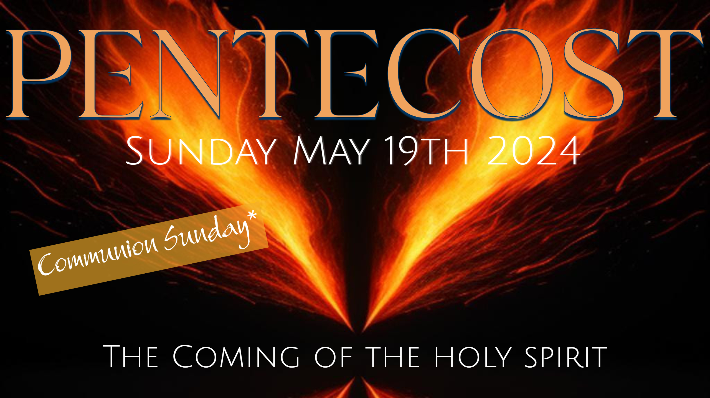 | SUNDAY’S @ 11:00AM
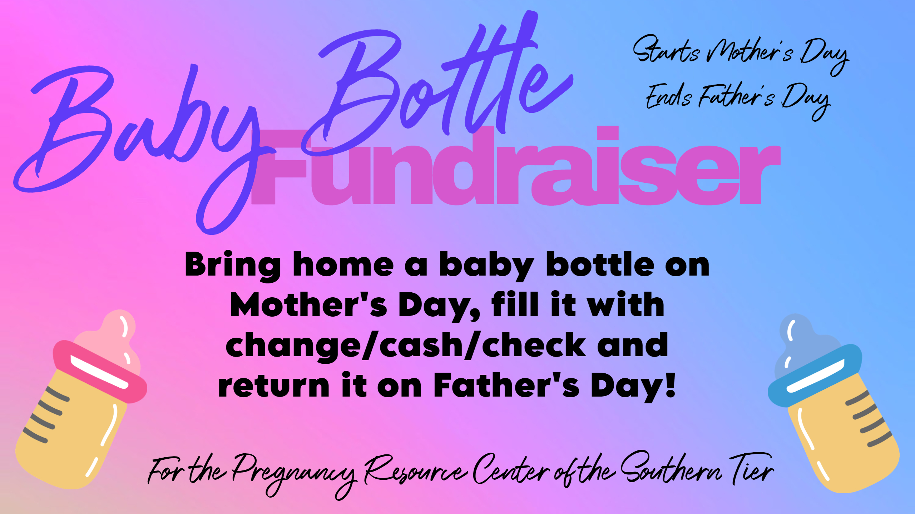
Where is the plate? | We do not pass a giving plate here at Freedom Center Church because 2 Corinthians 9:7 says, “So, let each one give as he purposes in his heart, not grudgingly or of necessity; for God loves a cheerful giver.” We are firm believers that the heart response is so much more valuable to the Lord than the amount placed in the plate. Read Luke 21:1-4!  Tithes and offerings may be placed in the “wooden church” on the back table.  We want you to grow and give when you are ready to give joyfully unto the Lord. If you would like to learn more about tithing, talk to Pastor Adrianna.

Memorial Day picnic is open to all. Come ready to enjoy sunshine, fellowship, and fun.  Want to be baptized? The Lake at Ives Run is a great place to embrace the waters of baptism. Let Pastor Adrianna or Pastor Rob know if you are interested.  Are you praying for the names on the Prayer Board to receive salvation?  Be looking for a special time of prayer coming soon! | 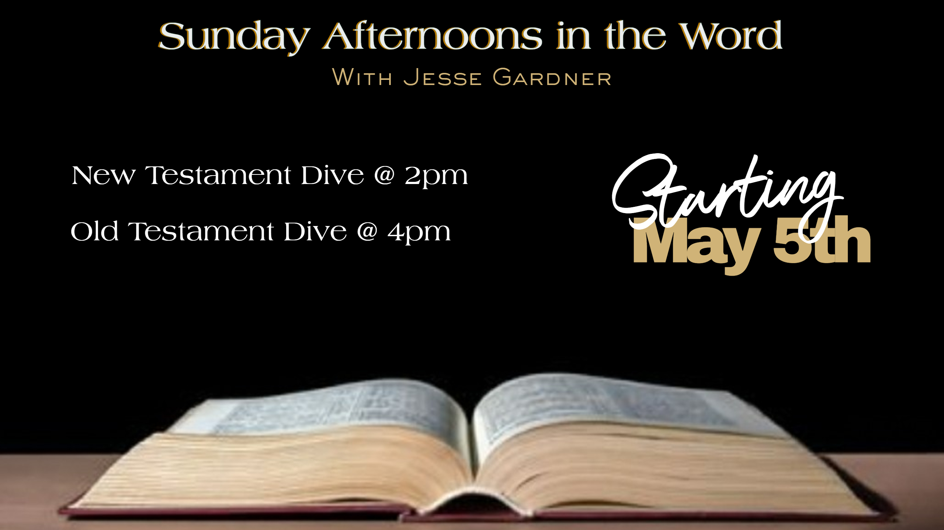 | Our mission statement is founded on the greatest commandments given to us, which can be found in Matthew 22:37-39 “Love the Lord your God with all your heart and with all your soul and with all your mind. This is the first and greatest commandment. The second is like it: ‘Love your neighbor as yourself.’” This seems simple, but there is a great deal of love, effort, trust, and sacrifice that goes into being able to fulfill these commandments.  At FCC we Focus on:  Step One: Loving God  Step Two: Loving Self  Step Three: Loving Others  And Finding Freedom  Freedom from Bondage  Freedom in Worship  Freedom to be Uniquely You  The vision is from Isaiah 58:9-12 and is to give ourselves on behalf of the needy and oppressed in the Christian community. This means everything we do throughout the year should have this as a focus.

